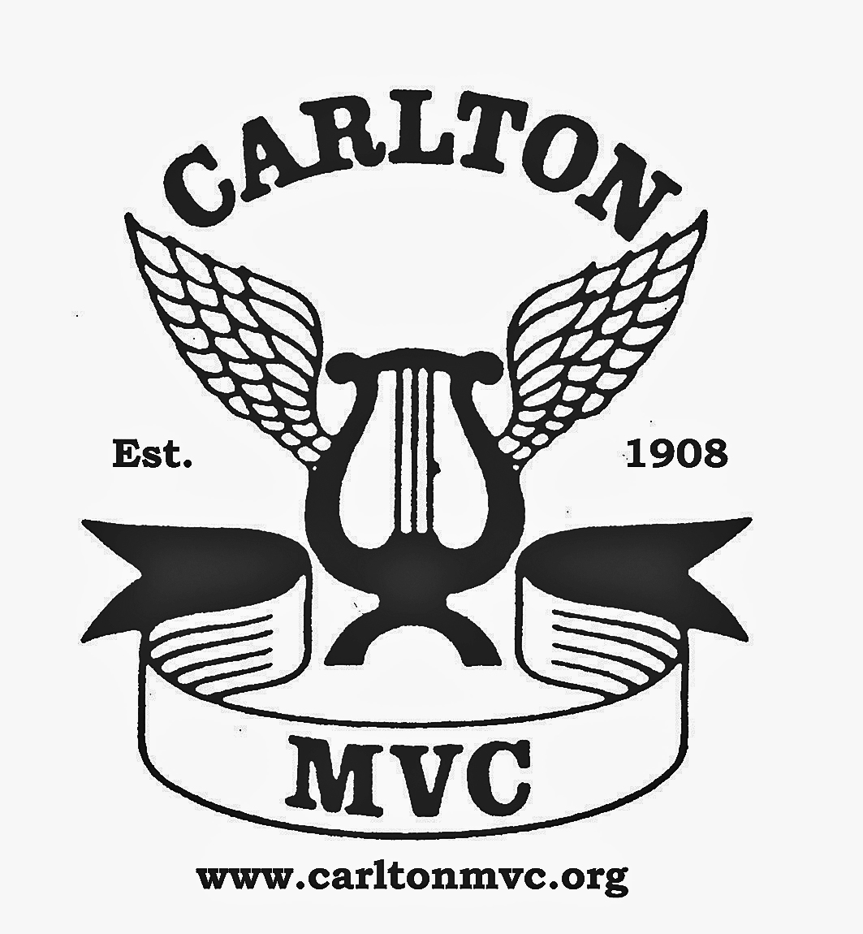
Carlton Male Voice Choir: Music Makers Award 2019

AN OPPORTUNITY FOR YOUNG MUSICIANS IN NOTTINGHAMSHIRE
The Carlton Music Makers Award, now in its nineteenth year, is a successful and well-established opportunity for promising young local musicians. You might like to visit the following link to find out about the young musicians who have won the award in the past: http://carltonmvc.org/music-maker-competition
As a local choir, Carlton is keen to encourage and help young performers in the area to further their interest, skills and experience in live musical performance. Each year we award a young musician from Nottinghamshire the Carlton Music Makers Trophy, a £1,000 cash prize (designed to assist the winning student in his or her musical studies) and an opportunity to perform to a large audience. The winner will be presented with the Music Makers Trophy at our annual Festival Concert at the Albert Hall Nottingham, where he or she will put on a performance programme of about ten minutes’ duration (and possibly a combined item with the choir).
Criteria for entry:
The Music Makers Award is open to any young musician in Nottinghamshire who, on the entry date, 1st February 2019, has passed their 16th birthday but has not reached their 20th birthday. Previous winners are not entitled to re-apply regardless of instrument choice.
Applicants should:
- be studying music at A or AS level AND/OR receiving private music lessons (the student may also have left school recently or be in a “gap year” before entering university or college.)
- have the ability to perform at Grade 7 or higher on a musical instrument or voice
- be available to give a 10 minute performance at the choir’s Festival Concert on 27th April 2019.
The student should:
- Arrange to record a video of their performance. (This should be no more than 6 months old). Please ensure that the video is of a reasonable quality of both video and audio as this will be used by the judges to make their decision. Consider carefully the location (background etc) the performance itself and how you present yourself. The judges will be looking at factors to include ability, accuracy, dynamics, passion, programme choice, presentation and stage craft. The standard of competitor is always high and it would be a shame for a good performance to be disadvantaged due to a poor quality presentation (use of mobile phones is not advised for this reason).
- Complete the entry form in full
- Send the video recording (on a DVD) and entry form to the address below.
OR:
- Upload the video recording to ‘youtube’ or similar video website and email the link to gbrooks147@msn.com along with the entry form.

Entries must reach the address below by 1st February 2019.
All participants will be notified of the decision by the beginning of March 2019.

The winner will be expected to perform for about ten minutes and formally receive the Award at the Carlton Male Voice Choir Festival Concert on the evening of Saturday 27th April, 2019 , at the Albert Hall in Nottingham. Help will be available from the choir in the time leading up to the concert, including accompaniment if required.

Thank you for taking the time to read this information. If you would like to know more, please do not hesitate to contact me on gbrooks147@msn.com or phone 07872968400

Yours sincerely,
Geoff Brooks Carlton Male Voice Choir, Music Makers Award Coordinator
Address for entries: G Brooks, 57 Highfield Drive, Carlton, Nottingham NG4 1GF

